# Structures Worksheet

You have been asked to read the products text file (it is a comma separated value file that has been exported from excel.) The user will type in an id, the product associated with that id should be displayed.

Please note, your code should make use of structs.

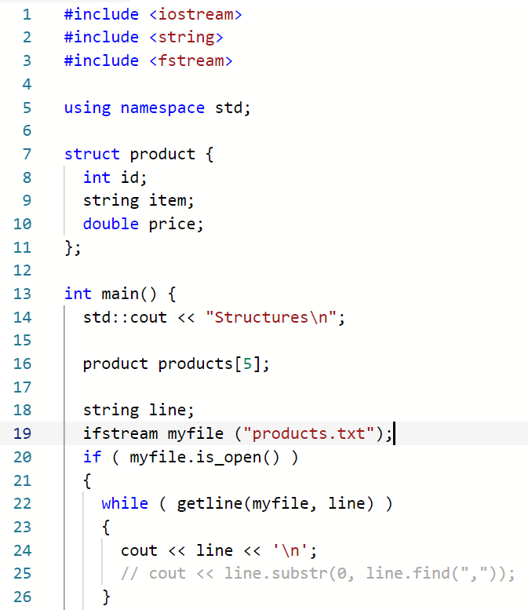

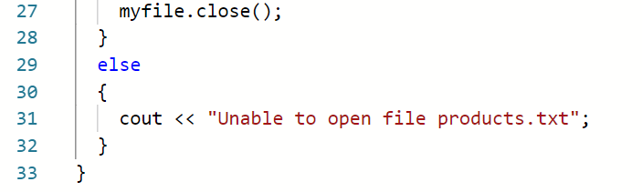

The products .csv file

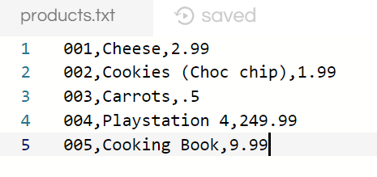

## Tasks

1. Enter the above code and ensure it works
2. Uncomment line 25, this should extract the ID from the line of text
3. Extract all three values from the line of text, ID, Product and Price
4. Use these values to create a product (struct)
5. Use the notes from the lecture, create an array of 5 products
6. Allow the user to enter a product id.
7. Search the array for that ID
8. Display the product